Name: Krish Thakkar

Class: IS 6640-090

UID: U1495638

Date: October 14, 2023

Lab 2

Question 1:

Question 2:

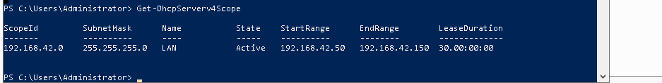

Question 3:

DHCP Questions:

1. What is the purpose of DHCP?

DHCP also known as Dynamic Host Configuration Protocol is a protocol which automatically allocates IP addresses and respective network configuration information to devices on TCP/IP. It simplifies the process of managing IP addresses by dynamically allocating and releasing them as devices connected to the network.

1. Is DC1 a DHCP Client?

It typically does act as a DHCP client. DHCP server provides IP addresses to other devices on the network.

1. When other “servers” are added to the lab, should they be DHCP Clients?

Servers in a network usually have static IP addresses to ensure they have a consistent and known address. It’s common for servers to have static IP addresses because they provide services to other following devices on the respective network. As per the normal practise DHCP clients are typically are for device like Laptops and smartphones which usually bounce on and off the network.

1. Give examples of two IP addresses (that are 100 IP addresses away from each other but the last octet is not greater than .150) that newly added servers could use on this network that would NOT conflict with DHCP clients

The following are the two IP addresses that are 100 IP addresses away from each other but the last octet is not greater than .150 that newly added servers could use on this network that would NOT conflict with DHCP clients are:

1. 192.168.1.50
2. 192.168.1.150

Best Practise Questions

1. It is considered a best practise to utilize a separate user account for performing administrative actions. That is why you created three accounts, one of which was a domain admin. Why is this considered best practise?

In my opinion, using separate accounts for performing administrative actions is considered a best practice for the following reasons

1. Having administrative tasks done required all high level access privileges and including separate administrative accounts helps the admin limit the exposure of these privileges.
2. In case of threat actor having access to a regular account on the network they won’t have administrative rights, creating a secure network for the organization in case of giving up the system.
3. Structuring the network infrastructure with separate administrative users makes it easier for the head to track what changes are being made by who.
4. Assume that your domain has 200 user accounts and all users have laptops. User are Salespeople that are out of the office most days. Within one month all users will be on the network at least once, as they all attend monthly meetings at the main office. All 200 users will never be on the network at the same time because sales meetings occur in groups of 100 salespeople at a time once a week on Monday mornings. After the DHCP Server was set up, on the second week of the month some users complained that they could not get on the network. Explain why the DHCP lease setting on DC1 is wrong for the size organization and what reasonable value it should be changed to in order to service all 200 users properly.

In the case of 200 users and fluctuations of network access due to weekly sales meet with 100 individuals at a particular time, the DHCP lease duration should be amended based on the user requirements and usage patterns. The DHCP session lease setting on DC1 comes with challenges that it may conclude before some of the salespeople return to the network leading to have connections trouble.

In order to provide the service to all the users evenly the organization should have access to the network in the burst of 30 days before the requiring to renew. This practise will allow the sales people to attend the monthly meeting and may not be on the network for the rest of the weeks to maintain their IPs. The daily user’s or regular user’s lease will be renewed as needed. Long term lease will be required for device that are out of the office for the majority of the time like laptops used by sales individuals.

Having these 30 days or higher durations will ensure that all the users in the organization can have reliable access to the network during the monthly meeting without facing challenges of expirations.